Source codes

import cv2

import numpy as np

import matplotlib. pyplot as plt

img = cv2. imread('/Users/louis/Downloads/Bird 2.tif', cv2.IMREAD_GRAYSCALE)

rows, cols = img.shape

*# print (rows, cols)*

nrows = cv2. getOptimalDFTSize(rows)

ncols = cv2. getOptimalDFTSize(cols)

*# print(nrows, ncols)*

nimg = np.zeros((nrows, ncols))

nimg[:rows, :cols] = img

img = nimg

dft = cv2.dft(np. float32 (img), flags=cv2.DFT_COMPLEX_OUTPUT)

dft_shift = np.fft.fftshift(dft)

magnitude_spectrum = 20 * np. log(cv2.magnitude (dft_shift[:, :, 0], dft_shift[:,:,1]))

*# print(magnitude_spectrum)*

plt.subplot (121), plt.imshow(img,cmap='gray')

plt.title( 'Input Image'), plt.xticks ([]), plt. yticks ([])

plt. subplot (122), plt. imshow(magnitude_spectrum, cmap='gray')

plt. title( 'Magnitude Spectrum' ), plt.xticks([]), plt.yticks([])

plt. show()

rows, cols = img.shape

crow, ccol = rows // 2, cols // 2

r=30

center=[crow,ccol]

mask1 =np.zeros((rows,cols, 2), np. uint8)

mask2 =np.zeros((rows,cols, 2), np. uint8)

x,y=np.ogrid[:rows,:cols]

mask_area1=(x-center[0])**2+(y-center[1])**2 >=r*r

mask1[mask_area1]=1

mask_area2=(x-center[0])**2+(y-center[1])**2 <=r*r

mask2[mask_area2]=1

fshift1 = dft_shift * mask1

fshift2 = dft_shift * mask2

f_ishift1 = np. fft.ifftshift(fshift1)

f_ishift2 = np. fft.ifftshift(fshift2)

img_back1 = cv2.idft(f_ishift1)

img_back2 = cv2.idft(f_ishift2)

img_back1 = cv2.magnitude (img_back1[:, :, 0], img_back1[:, :,1])

img_back2 = cv2.magnitude (img_back2[:, :, 0], img_back2[:, :,1])

plt.subplot (121), plt. imshow (img_back2, cmap='gray')

plt.title('Inside r=30'), plt.xticks([]), plt.yticks([])

plt.subplot (122), plt. imshow(img_back1, cmap='gray')

plt.title ('Outside r=30'), plt.xticks([]), plt.yticks([])

plt.show()

temp=ncols/2

arr=np.copy(dft_shift[:,:int(temp)])

for i in range(25):

max_value= np.max(arr)

index=np.where(arr== max_value)

arr=np.delete(arr,index[0])

print("At index:", index[0], " DFT frequency=", max_value)

Plot of DFT magnitude in Log scale

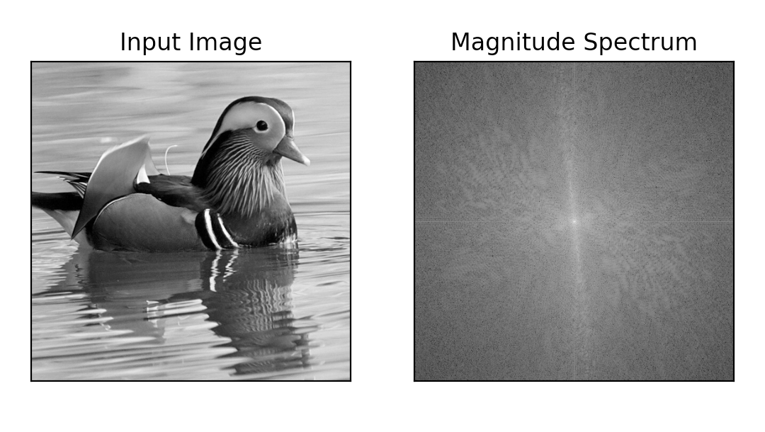

Image constructed by DFT coefficients inside the circular region with radius = 30

pixels

Image constructed by FT coefficients outside the circular region with radius = 30

pixels

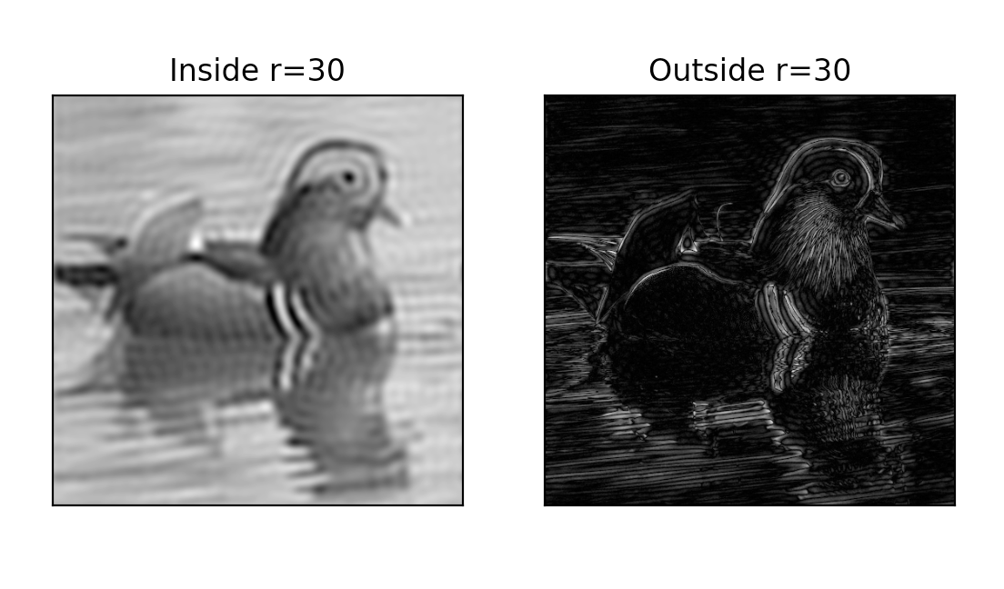

Table of top 25 DFT frequencies (u,v) in the left half frequency region (OsusM-1,

0<V≤N/2-1)

At index: [256] DFT frequency= 3137758.2

At index: [131582] DFT frequency= 3137758.2

At index: [131580] DFT frequency= 2147485.0

At index: [132091] DFT frequency= 1349696.2

At index: [132089] DFT frequency= 1242271.2

At index: [130046] DFT frequency= 1181857.5

At index: [133110] DFT frequency= 702304.75

At index: [132594] DFT frequency= 636582.56

At index: [127486] DFT frequency= 512254.44

At index: [131062] DFT frequency= 484831.8

At index: [131066] DFT frequency= 484798.5

At index: [130552] DFT frequency= 474234.3

At index: [132592] DFT frequency= 471952.8

At index: [130552] DFT frequency= 447097.8

At index: [131063] DFT frequency= 417929.7

At index: [133101] DFT frequency= 366208.7

At index: [130040] DFT frequency= 342861.38

At index: [130037] DFT frequency= 341783.22

At index: [135148] DFT frequency= 322466.12

At index: [128507] DFT frequency= 322132.06

At index: [130540] DFT frequency= 318228.56

At index: [135656] DFT frequency= 311429.47

At index: [129013] DFT frequency= 298685.56

At index: [127485] DFT frequency= 271465.1

At index: [134118] DFT frequency= 264660.38